**Group Project MS1 - Discovery Phase**

**DIG4104C - Web Design Workshop 1**

**FALL 2021**

**Group #5:**

Titionna Batista

Danny Acosta Forte

Ellery Hunt

Juliana Macedo

Maria Onde

Mark Anthony Yanit

**1. CONTENT ANALYSIS**

**Existing App:** [**PICTOFiT**](https://apps.apple.com/at/app/pictofit-shopping/id1527419372?l=en) by [Reactive Reality](https://www.reactivereality.com/)

* A. Site Inventory
  + **Shop** - Displays the available clothing items from miscellaneous stores
    - Filter Icon
      * Toggle between categories of clothing item (coats, dresses, jeans, etc.) and brands
  + **Dressing Room**
    - Items
      * Displays the avatar and the clothing currently in the user’s cart, allowing it to be tried on by the avatar
    - Scene - Allows users to change the background behind the avatar. Currently has four options.
    - Share - Allows user to share an image of the avatar wearing the clothes on top of their chosen background
  + **Avatars** - Displays 7 2D models for use in the Dressing Room  
    - Capture New Avatar - Uses the phone’s camera to capture a likeness of the user to then place onto a virtual model
    - Sign In - Signs user in to account to create model; required
      * Register - Necessary if the user does not have an account. Take in email and password.
  + **Check Out** - Shows items selected during shopping along with quantity, price, shipping, and the total. The user can push the check out on the bottom to complete their purchase.

- B. Media

- **Clothes** - Images of clothes of partnered clothing companies.

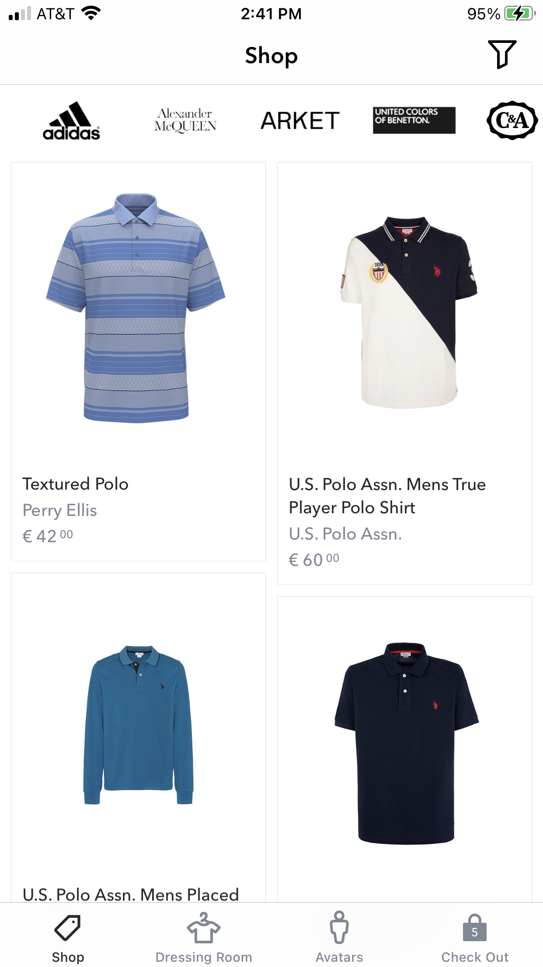

- **Avatar** - 3D model created using users measurement or default avatar used to try on clothing.

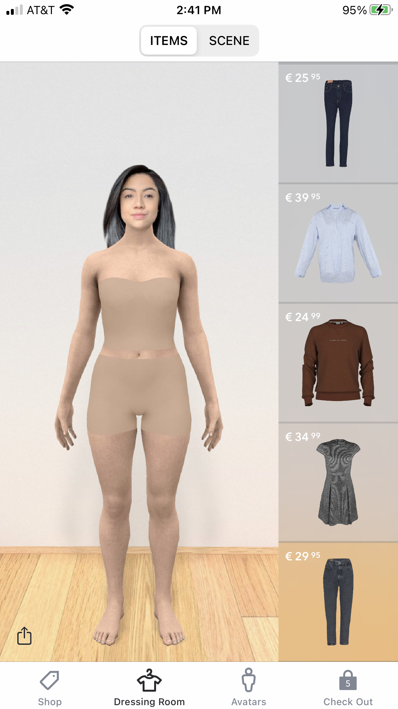

- **Icons** - pictogram used to help users navigate through applications.

* + - Icons Displayed
      * Shop, Dressing room, Avatars, and Check Out.



* C. Recommendations

- **Shop:** Allow user to start off by choosing what brand they want to look at first, and possibly choose their preferred 5-10 stores to initially be displayed  
  
- **Dressing Room:**  Allow the user to change the colors and sizes of a piece of clothing while it’s still on the virtual model to be better mixed and matched with other items. The dressing room should also allow pinch and drag gestures so the user can rotate their avatar to view the garments on the model from multiple angles.  
  
- **Avatars:**  More diverse body types and ethnicities to encourage a more personalized experience, as well as allowing the user the option to make an avatar of their own with their own measurements  
 - Sign In: Sign-in should show up after the user intends on leaving the app, asking if they want their content to be saved so that they can experience the avatar creation process and decide if they want the app to store their information or not. Other incentives for creating an account could also be offered, such as personalized clothing recommendations and the ability to mix and match clothes on avatars.  
  
- **Check Out:** Link item to original store’s app or website in user’s preferred browser to complete purchase

**2. SITE MAP**

* **Top Navigation Bar**
  + App Logo
  + Account Profile
    - Sign In
      * Account Info  
         - Email/Update Email  
         - Password/Change Password  
         - Username/Change Username
      * Measurement Adjustments
      * Settings
        + Light/Dark Mode Adjuster
        + Terms of Service
        + Help
        + About
        + Security

Delete Account

* + - * Sign Out
* **Bottom Navigation Bar**
  + Shop (Left Tab)
    - Search Bar
    - Filter Button
      * Brands/Partnered Stores
      * Categories
    - Clothing Items Inventory
      * Selected Item Overview
        + Recommended size for an item
        + Add to the dressing room
  + Dressing Room (Home/Landing Screen/Middle Tab)
    - Avatar and Clothing Display
    - Preset Default Avatars
      * Measurements Adjustment
    - Create Personal Avatar
      * Measurement Adjustment
      * Sign Up Button
  + Likes (Right Tab)
    - Filter Button
      * Brands/Partnered Stores
      * Categories
    - Clothing Items Inventory
      * Selected Item Overview
        + Recommended size for an item
        + Add to the dressing room

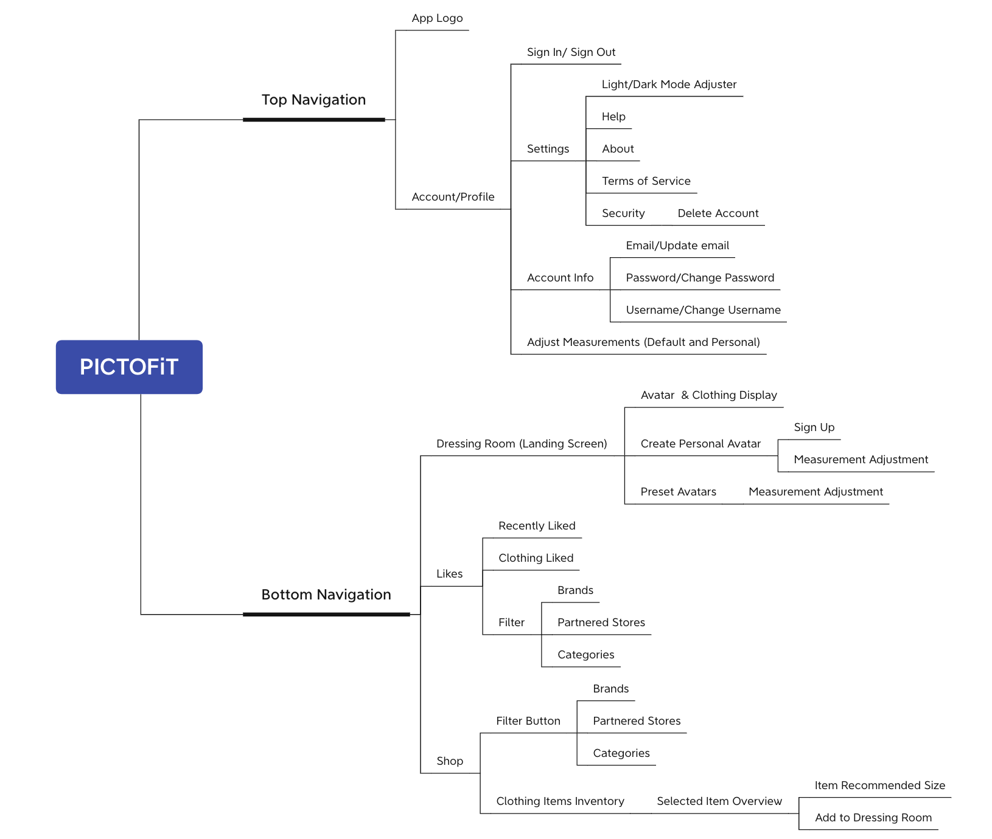

**3. STRATEGY GUIDE**

Moving forward with changing PICTOFiT and improving the app overall will take time. This Strategy Guide serves as an outline for our overall plan to make this happen.

PICTOFiT’s marketing strategy needs to be improved upon. We need a heavier presence on social media. Ads on Instagram, TikTok, and Facebook are extremely important in order to appeal to our target audience, females within the Gen Z and Millennial age range (ages 15 - 40). We are focusing on this demographic because they shop online the most according to [Total Retail](https://www.mytotalretail.com/article/how-gen-z-and-millennials-are-influencing-the-future-of-shopping/). We plan on marketing PICTOFiT to a larger and more diverse audience. PICTOFiT’s preset Avatar options currently consist of white models who have a smaller and more fit body type and are not customizable. The new PICTOFiT will give users more diverse options with the preset Avatars, including Avatars of different ethnicities, shapes, and sizes. We will also allow users to adjust the preset Avatars to reflect them and their body type if they don’t feel comfortable with the personalized face and body scan option. Currently, the majority of clothing options available on PICTOFiT are from expensive and luxury brands such as Alexander McQueen, Gucci, Philipp Plein, J. Crew, Louis Vuitton, Polo Ralph Lauren, Paul Smith, and more. Out of the thirty brands listed on the app, only five of them are known for being trendy and affordable. PICTOFiT is being seen as unavailable to inexpensive stores, therefore not designed to serve the middle and lower class. PICTOFiT is non-inclusive and is serving a very small demographic. Due to the political climate and just pure morals and ethics, catering primarily towards the white upper class is a huge issue. The new PICTOFiT will include clothing items from more affordable retail stores. Due to the rise in sales within the online fast fashion industry, we also want PICTOFiT to partner with fast-fashion online stores, because doing so will bring more attention to PICTOFiT. The marketing strategy with fast-fashion online stores needs to be different than it is with other brands. Considering that popular fast-fashion sites, such as Shein and Romwe, release over a thousand new items each day, staying up to date with products would be practically impossible for PICTOFiT. However, Shein and Romwe do have exclusive collections that are only released about twice a season. These collections are typically a partnership between a well-known brand or celebrity, making them extremely sought after. Due to the fact that these collections are typically fairly small, usually containing between fifty and forty clothing items, PICTOFiT would be able to keep up with the merchandise.

The strategy for presenting PICTOFiT to brands should also be different. Right now Reactive Reality is marketing PICTOFiT to brands promoting the fact that they can improve sales but neglecting to tell companies how much money they can save in reduced product returns with PICTOFiT. Showing companies this information with statistics and studies, will give them another reason to partner with PICTOFiT and put their merchandise on the app.

We will also be changing the overall design and layout of the app to improve the user experience. We plan on having three tabs within the bottom navigation bar, (from left to right) Shop, Dressing Room, and Likes. The Profile tab will be in the top navigation bar along with the app’s logo. The Shop tab will be where users can view various clothing collections and “like” the items they want to try on in the Dressing Room. Users will be able to filter the brands and categories within the shop either using the filter tool or the search bar for maximum efficiency. The Dressing Room tab will function as the home/landing page. This is where users can try on clothes, customize their personal Avatar, make adjustments to their Avatar’s measurements, and sign up for an account if they wish to save their data. The Likes tab will be where “liked” clothing pieces are saved for future reference. We will be removing the “check out” feature from the current version of the app and instead, providing users with a link attached to the specific piece of clothing they “liked” so they can purchase it straight from the brand’s website. This interface reconstruction will add necessary elements and better organize existing ones, making it much easier for the user to navigate and providing a better overall experience within the app. A detailed site map can be examined in the attachments above.